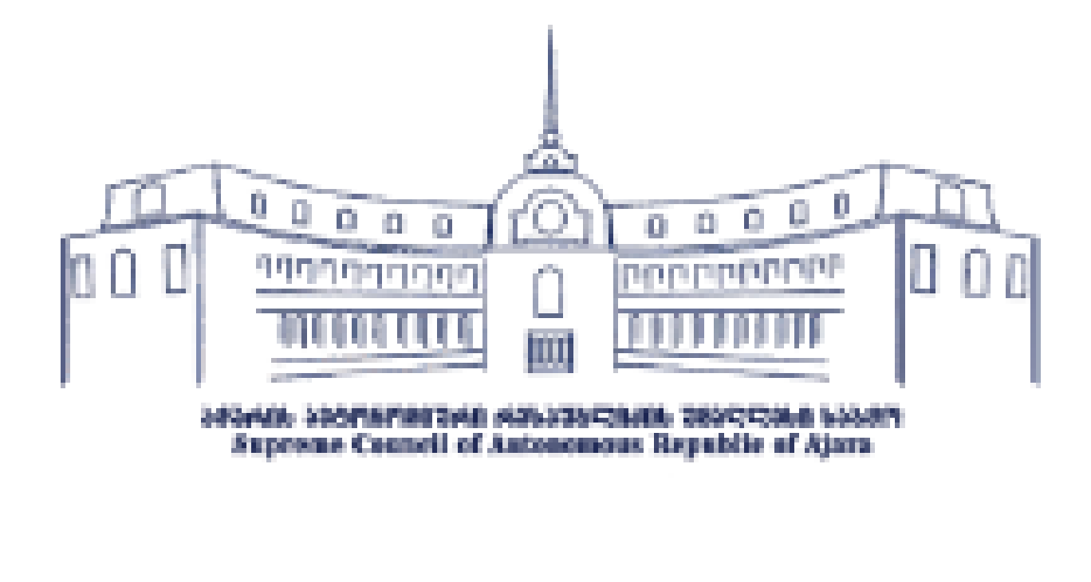

Communication Strategy and Action Plan of the Supreme Council of the Autonomous Republic of Ajara
2021-2024

სSeptember, 2021
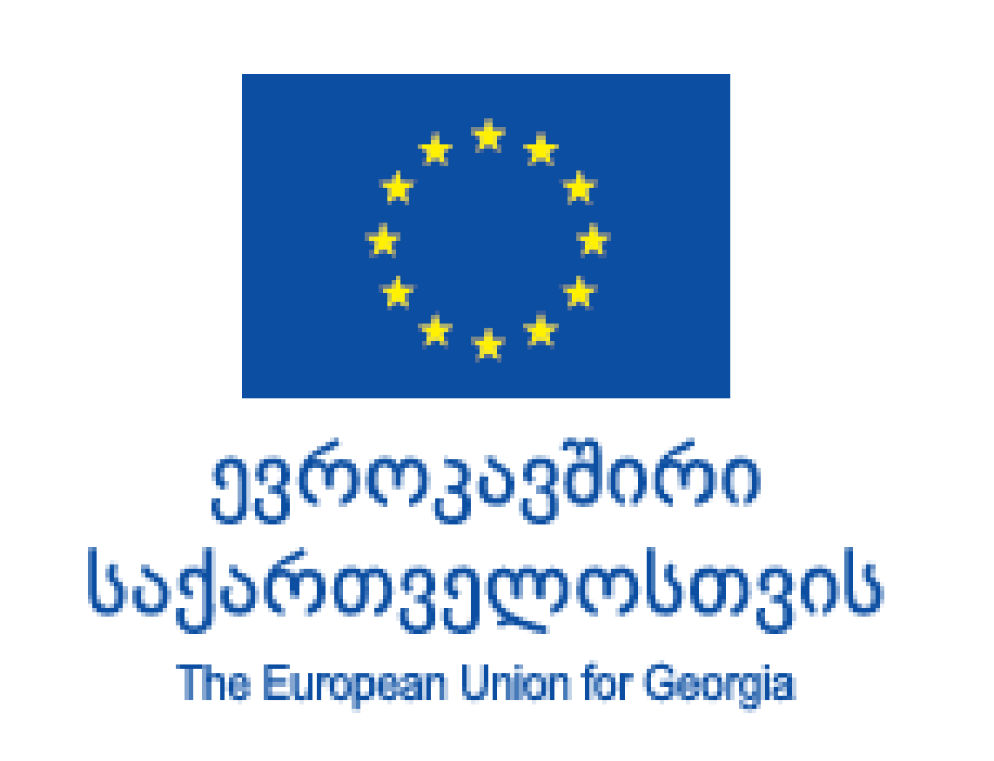

Communication Strategy and Action Plan were developed by the Supreme Council of the Autonomous Republic of Ajara in cooperation with the Consulting Company PMO and with the support of the European Union (EU) and the United Nations Development Program (UNDP). The views expressed in this document are those of its authors and do not reflect the views of the European Union (EU) and the United Nations Development Program (UNDP).

Table of Contents
Introduction 4
Methodology 4
Situation Analysis 5
Internal Communication of Supreme Council of Ajara 6
External Communication of Supreme Council of Ajara 6
Main challenges 7
Internal Communication Challenges 7
External Communication Challenges 7
SWOT Analysis 8
Communication Strategy Vision 9
Principles 9
Target Audience 9
Main Messages 10
Communication Channels 11
The Strategic Communication Goals and Objectives of the Supreme Council of the Autonomous Republic of Ajara 14
Strategic Goal N1: Provide a Continuous Cycle of Information within the Council and Create an Internal Organizational Culture 14
Strategic Goal N2: Establish an Inclusive External Communication System 14
Strategic Goal N3: Increase the Reputation of the Council 15
Appendix 1: List of Literature 16

Introduction
Communication Strategy of the Supreme Council of Ajara is a framework document aimed to strengthen internal and external communication instruments of the Council as well as increase its visibility and authority.
A Communication Action Plan accompanies the strategy document. Both documents are an integral part of the Institutional Development Strategy. The communication strategy is also in line with the Open Governance Council Action Plan 2020-2021.
This document is prepared with the support and in the framework of the European Union and the United Nations Development Program (UNDP) project - "Consolidating Parliamentary Democracy in Georgia"; under which strategic documents were developed with the support of the consulting company PMO.
This document will help strengthen the Council’s communication abilities, intensify the strategic communication planning process, identify further steps, and ultimately improve the Council’s reputation and image.

Methodology
Consultations, workshops and in-depth interviews were conducted during the drafting stage of strategic documents; all the existing documents regarding communication of the Council were analyzed.
During the development of the communication strategy, 15 interviews were conducted with the internal and external stakeholders of the Supreme Council of Ajara, including representatives of the government, opposition, civil society, international organizations and the media.
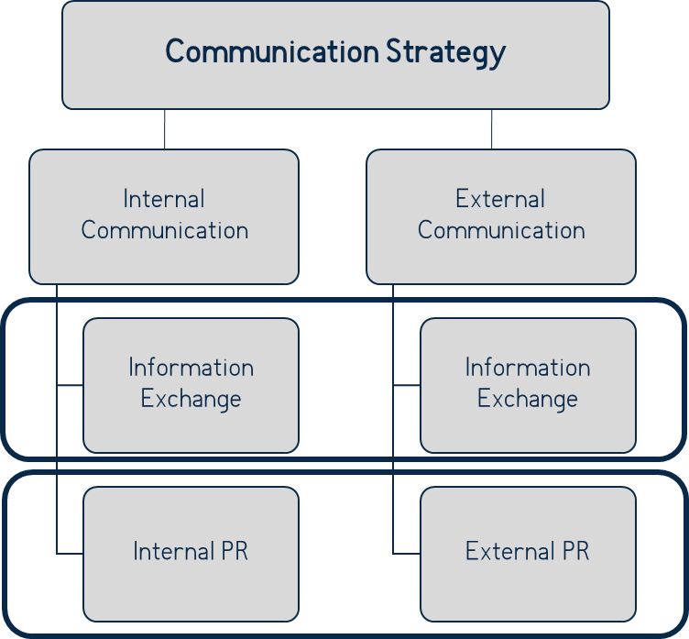
In the process of developing the communication strategy of the Supreme Council of Ajara, the target groups of the Supreme Council were determined, the main communication messages were defined and the communication channels for specific groups were selected. After carefully analyzing the main challenges and the SWOT analysis, three communication strategic goals of the Supreme Council of Ajara and relevant objectives were formed, which were conveyed in detailed actions and steps.
The strategic goals were formulated in accordance with the target audience and key messages of the Supreme Council of Ajara, as well as taking internal and external challenges into consideration.
The Council's communication strategy is divided into two areas: internal and external communications. Both directions foresee an uninterrupted exchange of information, as well as strengthening the reputation and image of the Supreme Council of Ajara.
The internal and external directions of strategic goals are radically different from each other in terms of target groups, although their interrelationships are important. If the internal communication of the Council is strong, the process of external communication and openness will be carried out accordingly. Each step taken to increase internal PR and employee pride will help strengthen the reputation of the Supreme Council of Ajara and quality public relations to enhance its overall/external reputation.

Situation Analysis
Public Relationship and Protocol Department (PR Department), as well as the Office/Staff of the Chairperson of the Supreme Council, are in charge of the Supreme Council of Ajara's internal and external communications. Public relationship direction is currently led by the PR Department, while the communications of the Council’s Chairperson individually, is led by the Chairperson's Office.
The PR Department is primarily responsible for communicating with the media, which includes emphasizing the Council's role and importance, communicating the work process, preparing messages, statements, and other information related to the Council's ongoing processes; as well as disseminating information about Council events and meetings. In addition, the mentioned Department has also obtained the function of managing the protocol activities.
It should be noted that the above-mentioned Department's and the Office of the Chairperson activities somewhat intersect. The Office chooses the Chairperson's personal communication channels, manages their personal page, composes messages, chooses target groups, and plans and organizes meetings. Members of the Office team are also involved in international relations.
The Supreme Council of Ajara committees have individual action plans that include elements of external communication. These plans, however, do not take into account the short and long-term public relations strategy and related activities. It is important to have a joint communication strategy that defines communication channels, key communication messages, and target groups; Its strategic goals and objectives will be clearly defined, and they will correspond to the individual action plans of each committee and subsequent departments. Taken together, these initiatives will help to improve the quality of communication with the public, raise awareness of the Council's work and accomplishments, establish smooth and consistent practices, and involve external stakeholders in the Council's work.
As previously stated, the Supreme Council of Ajara's communication includes both internal and external communication. These two areas are critical for strengthening the stakeholders and communicating key messages to all target groups.
When discussing target groups, it is critical to mention both communicating with the local audience and international relations, which are currently managed by the Chairperson's Office. These activities should preferably be reflected in the Council's communication strategy as well as relevant action plan. The document should bring together all o target groups, allowing the implementers of the strategy and action plan to view the goals of communication with all relevant groups and the methods of implementation in a single context.

Internal Communication of Supreme Council of Ajara
Internal communication of the Council includes the exchange of information between the committees and various structural units of the Council. At this stage, internal communication takes place at the level of personal relationships, using closed chat groups (mainly through the WhatsApp platform) or face-to-face communication.
Close cooperation between the Public Relations Department and the Office of the Chairperson is important, as one of the duties of the Department is to support the Chair through communication with various parties, including the media, citizens, donors, and other stakeholders.
The official case management process is organized in accordance with the existing legislation or internal regulations, which ensures that the incoming letter is not left unanswered. The coordinated exchange of information on the Council's accomplishments, news, and various activities, on the other hand, is fragmented.

External Communication of Supreme Council of Ajara
First of all, the Supreme Council's external communication involves relationships with the citizens, the media, state departments, and various local or international partners.
At this point, the Council's communication with the public about its role and function is insufficient, resulting in a lack of awareness of the Council activities. There is an absence of active communication with non-governmental organizations (NGOs) and representatives from various business sectors, and their participation is not ensured through systemic approaches.
The relationship between the media and the Supreme Council is primarily mediated by the Head of the PR Department, which is frequently viewed solely as a press service. It should be noted that the Council has approved a new media accreditation system, that has established certain procedures in the communication process; although, some media outlets have perceived this as a barrier in communication.
In terms of relations with the government, relationships between the Supreme Council's committees and the executive bodies of the Autonomous Republic are handled by the staff of the relevant committees of the Council; and communication with municipal bodies is managed by majoritarian members of the Supreme Council. As for the Georgian Parliament, the communication process is not specified, and relations between the two bodies are mostly conducted by the Chairperson of the Supreme Council or the Head of Administration (Chief of Staff).

Main challenges
The Communication Strategy document includes analysis of the key challenges based on in-depth interviews with the parties involved in the communication process, as well as the Council Needs Assessment Report and other desk documents developed with the active participation of Council members and Staff.
The Supreme Council's communication challenges are divided into internal and external directions; however, it should be noted that the Public Relations Department and the Chairperson's Office need to approach the implementation of both internal and external communication goals systematically.

Internal Communication Challenges
- Lack of internal organizational information exchange and communication cycle - at this point, the exchange of information among Council Members is informal. Internal communication approaches have not been established. Current news and activities in the Council cannot always be communicated to or between members, committees, and departments in a timely and systematic manner. As a result, neither the Council Members, nor its employees feel a sense of loyalty or employee pride towards the institution, endangering the Council's image.
- Lack of competencies of the strategic communication team - the existing strategic communication team needs to be strengthened so that they can fully accomplish their assigned duties and communicate more effectively.
- Lack of execution of the Code of Conduct and Ethics - currently, the Supreme Council of Ajara has a written code of conduct and ethics, but the execution is fragmented. As a result, the Code falls short of adequately regulating mutual respect and communication among Members.

External Communication Challenges
- Insufficient mechanisms of citizen engagement - at the moment, mechanisms for citizen participation, which is a requirement for democratic and open governance, are almost non-existent. However, it is critical in terms of increasing public awareness of the Council's activities. As a result, citizens are unable to participate in legislative activities and obtain adequate information about the mechanisms available to them.
- Lack of application of the Open Governance principles - the Supreme Council introduces the principles of open governance, though it is primarily carried out by senior management. The perception of open governance principles among council staff is fragmented.
- Lack of awareness about the activities of the Council - In the region, there is low awareness of the Council's activities; In addition, public participation in the Council's activities is rare.
- The low reputation of the Supreme Council of Ajara - Despite significant improvements in recent years, the Council's reputation remains inadequate. The activities and image of the Council's members also have an impact on the Council's reputation, which is often overlooked.
- Lack of relationship strategy with donors and international partners - at this point, the Chairperson personally, is the one involved mainly in relations with international partners. Concrete steps or responsible parties are not determined in this direction.

SWOT Analysis
Strengths
- Readiness for more publicity and community involvement
- Positive steps in the field of international relations
- Existence of an Open Government Council and its action plan
- Existence of action plans of sectoral committees
- Media connections and willingness to cooperate
Weaknesses
- Lack of a unified vision and action plan for the Council communication
- Fragmented experience of citizen engagement
- Uncoordinated communication within the Council
- Unsystematic communication with the executive body
- Lack of usage of communication channels
- Lack of qualifications in the field of strategic communications
- Lack of interaction with internal and external actors
- Limited financial, technical, and human resources
- Low reputation
- Lack of communication with donors
Opportunities
- Receiving assistance from the central legislature and / or executive branch to strengthen communications
- Receiving information and assistance from international partner institutions and donor organizations to strengthen communications
- Increased uptake of social media by the population
Threats
- Misinterpretation of information by the public
- Low interest from external actors
- Boycott by the media
- Tarnishing the reputation of the Council Members
- Damage to the Council's reputation through misinformation

Communication Strategy Vision
Increasing the reputation of the Supreme Council of the Autonomous Republic of Ajara and strengthening the principles of citizen participation by establishing an interactive communication system with internal and external Council actors.

Principles
The Council's communication strategy is based on the following principles:
- Open / Public
- Transparent
- Responsible
- Innovative
- Inclusive
- Interactive
- Technologically powerful.

Target Audience
The Supreme Council of the Autonomous Republic of Ajara's target audience is divided into five groups: Members of the Council, the population, the media, public entities, and partners. Identifying target groups and planning communication suited to each of them is a critical step in developing a communication strategy. Proper and defined communication with target groups enables the target audience to receive accurate messages that are tailored to them in the most efficient way.
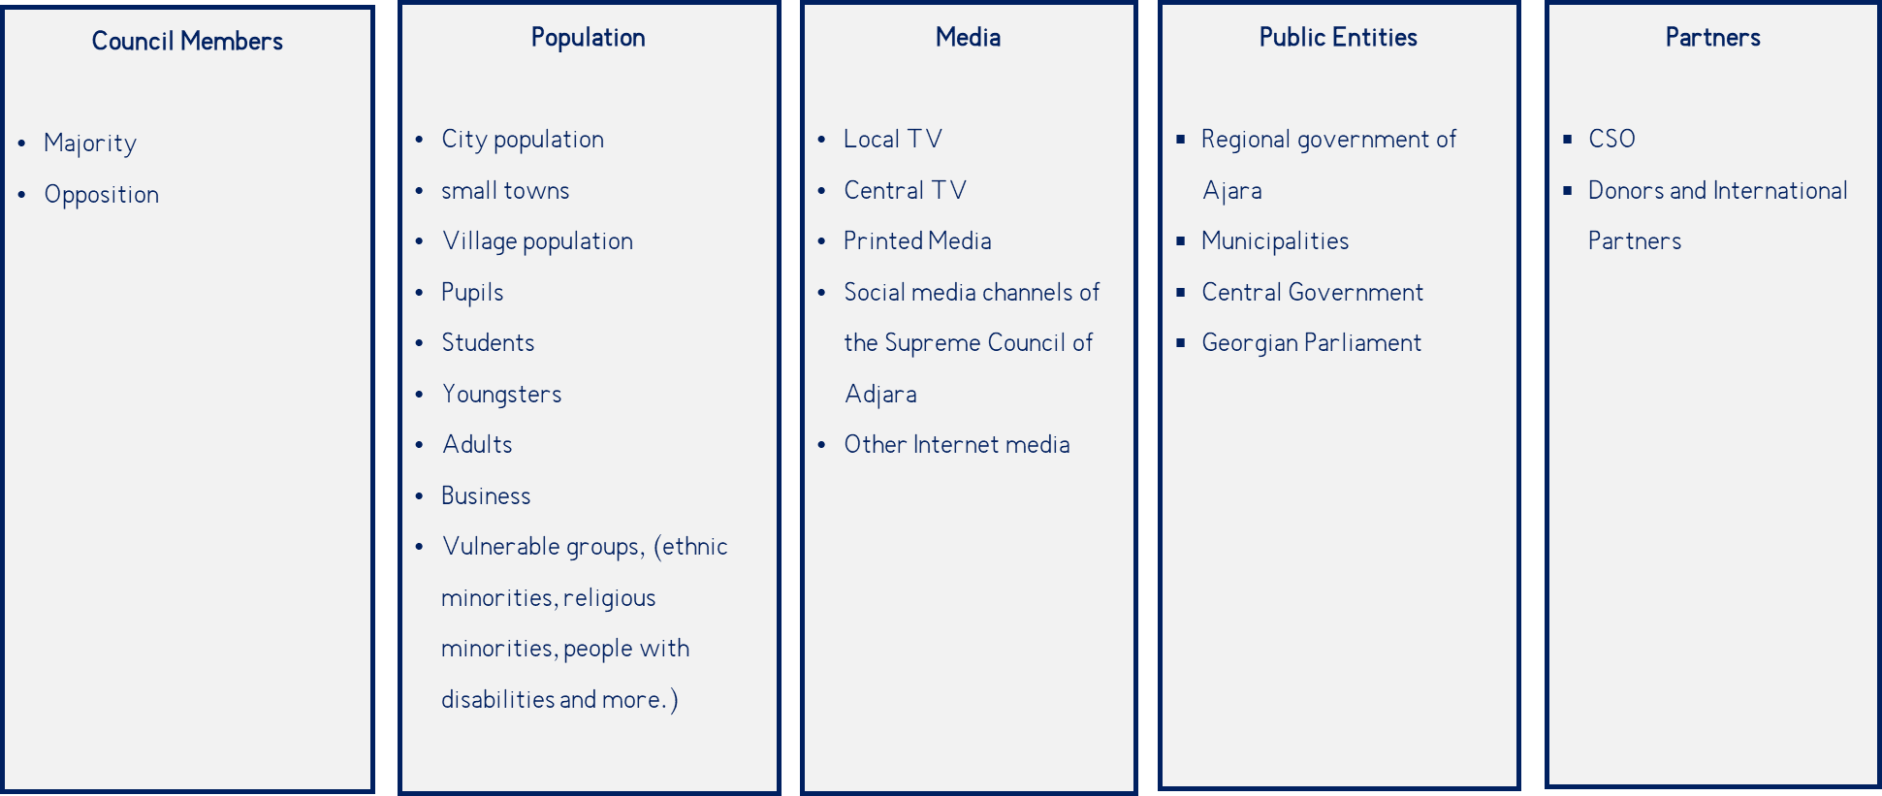
Target groups of the Supreme Council of the Autonomous Republic of Ajara:
Source: PMO Analytics PMO

Council members - This group includes Members of both the ruling party and the opposition of the Council.
Population - The largest target group, which includes the population living in cities, small towns and villages, schoolchildren and students, young people, adults and also vulnerable groups, such as, ethnic minorities, religious minorities, people with disabilities and more.
Media - Media is one of the most important groups and integrates both local and central televisions, print media, private social media channels and other internet media channels, that are also very active.
Public Entities - The Government of the Autonomous Republic of Ajara and the municipalities of the region are among the Council's target audiences and stakeholders; proper communication with the central government and the Georgian Parliament is also necessary.
Local and international partners - The Council actively collaborates with various donor organizations, as well as regions or parties from other countries; however, cooperation with CSOs, including local organizations, is critical to the region's interests.

Main Messages
Based on the values ​​and principles of the Supreme Council of the Autonomous Republic of Ajara, the main messages of the Council have been formed, which should be delivered to each segment.
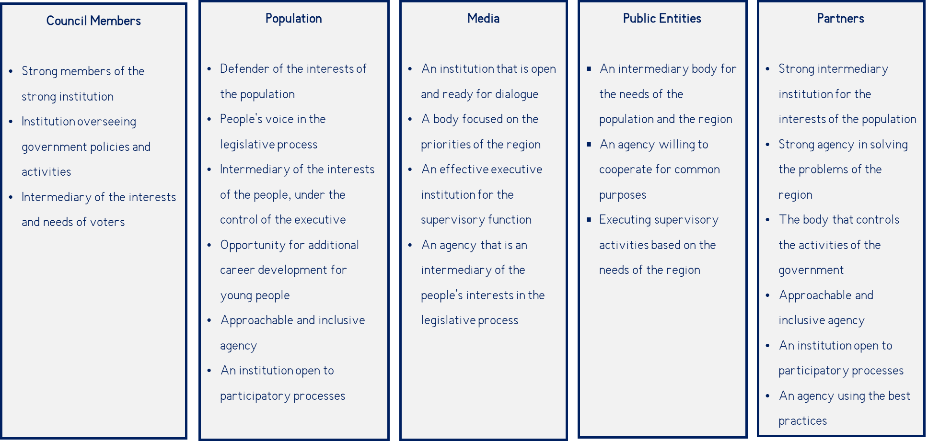
The main messages of the Supreme Council of the Autonomous Republic of Ajara to its target segments:
Source: PMO Analytics PMO
Members - it is important for each Council Member to feel that they are a part of a strong institution; that each of them is an integral part of the institution that oversees government policies and activities; and is an intermediary of the interests and needs of voters.
Population - it is important for the Council to be able to communicate with the public their image of a strong institution, to highlight its open and inclusive activities, to encourage people to be involved in lawmaking, to be Intermediary of the interests of the people, including through the control of the executive. Additional emphasis should be placed on empowering Council Members to help the Council become an attractive place for young people in terms of career development.
Media - it is important that the media perceives the Council as an open institution; as an institution and partner ready for dialogue and coverage support; as a body focused on the priorities of the region, and an effective supervisor.
State entities - it is critical to emphasize the role of the council as an Intermediary of the interests of the population and the region. Demonstrating the Council, as an agency working towards shared purposes dedicated to the common good of the region; and performing the oversight of the executive.
Partners - at the local level, the message for this group is the institutional strength and importance of the Council in resolving regional problems; the care for the interests of the people when performing legislative and oversight activities. Openness and inclusivity, which employs participatory processes. International partners must see the Council as being ready to implement the best practices.

Communication Channels
When developing a communication strategy, it is important to understand who the communication's target audience is and what the main message is for them. It is, however, equally important to determine which communication channels the Supreme Council should use to provide the information to the audience.
Communication channels of the Supreme Council of the Autonomous Republic of Ajara:
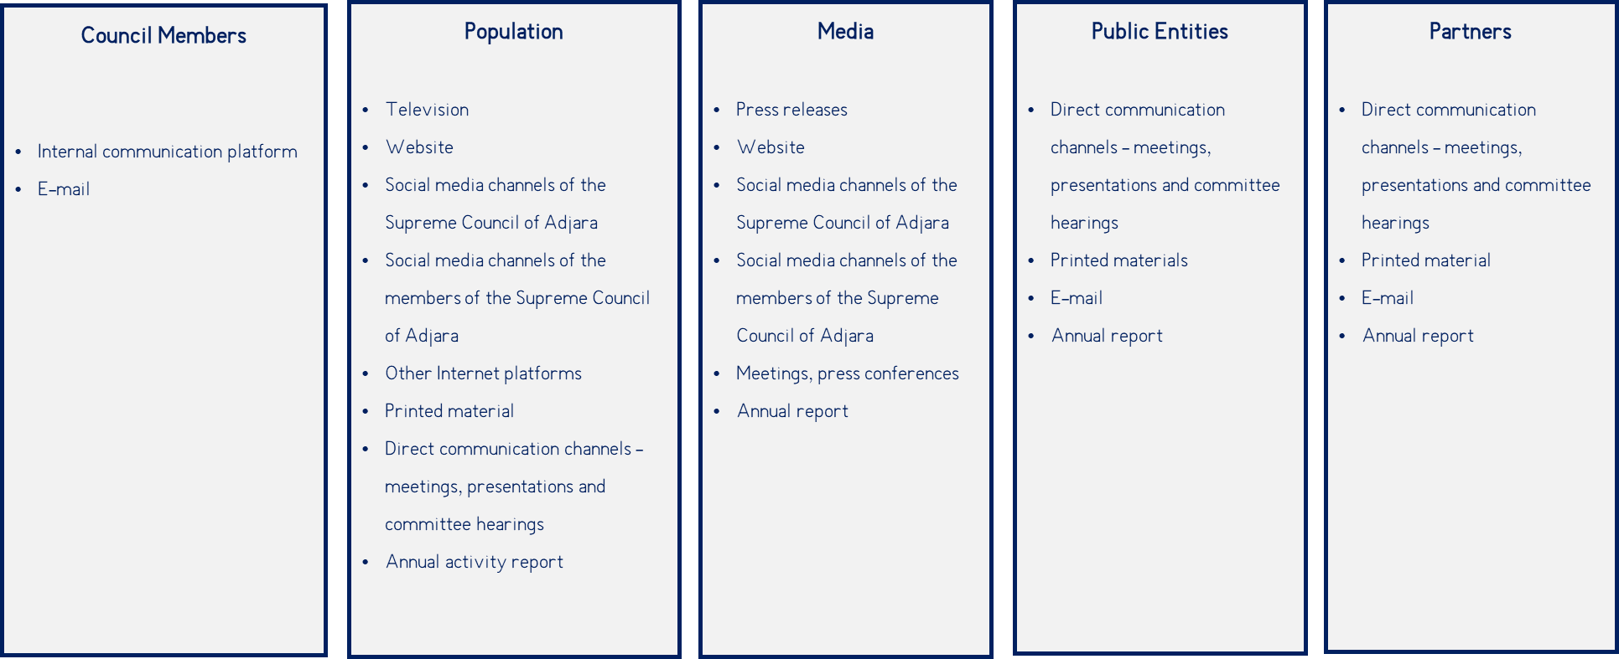
Source: PMO Analytics PMO
Council Members - A well-functioning internal communication platform and e-mail is essential for the smooth functioning of internal communication.
Population - This group requires almost all forms of mass communication, including television, the smooth and operational functioning of the Supreme Council's website, social networks of the Supreme Council and of its Members, and other Internet platforms. Furthermore, printed materials must be used to disseminate information about the Council's activities to people who do not have access to other forms of communication. Meetings, presentations, and committee hearings, as well as personal meetings of the Council Members and discussions on various activities, are all effective ways to increase public participation. The Annual Report demonstrates all activities and important decisions taken by the Council for public benefit.
Media - One of the most important factors for information dissemination is media involvement and ongoing communication with them. Therefore, press releases must be prepared for distribution to the media, press conferences and various meetings must be organized. Media outlets can also obtain information from the Council website, the Council and its Members social networks, and the Annual Report.
Public Entities - the Council should engage in direct communication with government agencies, including face-to-face meetings, presentations, and committee hearings. Furthermore, it is critical to communicate via e-mail and actively use the Annual Report.
Partners - It is critical for Council Members to communicate with partners in person through meetings and presentations, as well as via e-mail, which is the medium, through which the Newsletters, Annual Electronic Reports, and other information materials are distributed.

All the necessary communication channels that the Supreme Council might use, based on the target segments, were evaluated according to the significance. The ratings were distributed as follows:
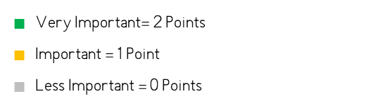
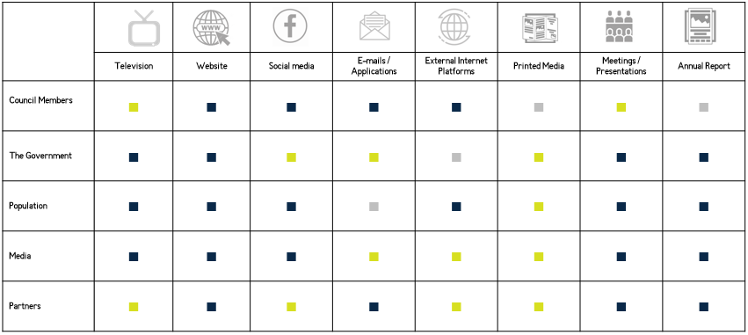
Source: PMO Analytics PMO
The distribution of the total scores of the target segment in each communication channel is as follows:
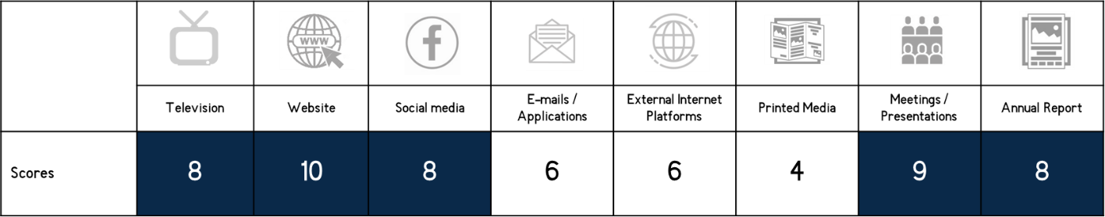
Scores indicate how important a particular communication channel is. Channels with 8 or more points are given high priority. As a result, attention should be paid to their development. In this case, such communication channels are: television, website, social media, face-to-face meetings and presentations, and Annual Report.
Each communication channel must satisfy and add value for the target segments that have been chosen. Different communication channels serve different purposes and have various levels of problem-solving ability. Achieving the desired result and implementing an effective communication campaign by utilizing the channels collaboratively and synergistically will be possible.
Television - The television, both local and national, is a major disseminator of information and communication channel. Through television, the Council is able to quickly disseminate information about its activities to the general public, especially in the areas, where there are no other means of communication.
Website - One of the main sources of information is the Supreme Council's website. It is an important channel for all of its target audiences in terms of news, events, and the information on the institution as a whole. The Supreme Council of Ajara can effectively communicate with all stakeholders by using this communication channel.
Social Media - Social networks are gaining more relevance and its consumption is increasing daily. Facebook, LinkedIn, YouTube are especially important social media channels.
E-mail and communication platforms – E-mail and applications such as WhatsApp, Facebook Messenger, Signal and others play an important role in both internal and external communication. The Supreme Council can ensure the smooth exchange of documents and information between employees through them; As well as ensure formal communication with local and international partners.
External Internet Platforms - In addition to the Supreme Council's social media page, it is critical to understand how other Internet platforms perceive and refer to the Supreme Council and its activities. The significant portion of the population gets their news not only from television but also from the internet.
Meetings / Presentations - Face-to-face meetings with various organizations, donors, and government agencies, as well as meetings in rural areas and villages where communication is limited or non-existent. These types of meetings will increase the involvement of this segment of the population, for which the Member activity is especially important.
Annual Report - The dissemination of the annual report, as well as other printed materials about the Council's activities, will help to raise awareness and highlight the activities and important decisions that have been implemented by the Council. It will also enable the Supreme Council of Ajara to analyze statistical data and inform the target audience of the outcomes.

The Strategic Communication Goals and Objectives of the Supreme Council of the Autonomous Republic of Ajara

Strategic Goal N1: Provide a Continuous Cycle of Information within the Council and Create an Internal Organizational Culture
The Supreme Council of Ajara, on the one hand, has a well-functioning internal communication system, which ensures the smooth information flow of all parties involved and promotes the effective performance of the main activities of the Council; and, on the other hand, has a strong corporate culture through which all employees of the Council feel valued, needed and they feel that they are a part of strong institution; accordingly, they transmit the value of the Council both internally and externally.
Objectives:
1.1 | Establishment of a system for the rapid exchange of information among and between the Council Members and the Staff
1.2 | Improvement of internal communication platforms and communication mechanisms in the Supreme Council of Ajara
1.3 | Developing internal organizational communication approaches that increase employee loyalty and strengthen the Council's image as a desirable and prestigious employer among employees
1.4 | Establishing a strong team in the field of strategic communication and ensuring its continuous development

Strategic Goal N2: Establish an Inclusive External Communication System
The Supreme Council of Ajara carries out result-oriented, inclusive and segmented communication with different parties. Actively uses citizen engagement mechanisms, ensures openness, access to information and accountability.
Objectives:
2.1 | Developing and implementing interactive citizen engagement mechanisms as well as a citizen feedback system
2.2 | Strengthening communication with the media about the functions of the Council
2.3 | Communicating closely and consistently with local and international strategic partners
2.4 | Establishing a process of systematic and coordinated information exchange with local and central executive authorities

Strategic Goal N3: Increase the Reputation of the Council
The Supreme Council of Ajara has established a positive image, has a strong reputation within the internal and external target audience.
Objectives:
3.1 | Increasing the awareness of the role and functions of the Supreme Council of Ajara
3.2 | Raising awareness of the Council activities in target groups using different communication channels
3.3 | Promoting existing citizen engagement mechanisms according to target groups

Appendix 1: List of Literature

- The IPU 3-Year Communications Strategy: 2019-2021, 2018.
https://www.ipu.org/sites/default/files/documents/3years_comm_strategy-en-28fev.pdf
- Open Government Permanent Parliamentary Council Communication Strategy and Action Plan,2019-2020 წწ.
https://idfi.ge/public/upload/IDFI_2019/ogp/council_strategy_geo.pdf
- Action Plan for the Open Government of the Supreme Council of the Autonomous Republic of Adjara for 2020-2021
http://www.sca.ge/res/docs/SCAAP-GEO.PDF
- UNDP, Strategies and good practices in promoting gender equality outcomes in parliaments, 2016.
https://www.ohchr.org/Documents/Issues/Democracy/Forum2018/UNDP_3.pdf
- New Zealand Parliament, Parliament Engagement Strategy, 2018-2021.
https://www.parliament.nz/media/5268/parliament-engagement-strategy-2018-2021.pdf
- The Government of Canada, Citizen Participation in the Legislative Process 2017-2018.
https://parlamericas.org/uploads/documents/Toolkit_Citizen%20Participation%20in%20the%20Legislative%20Process.pdf
- European Youth Parliament, Communication Strategy, 2018.
https://members.eyp.org/sites/default/files/eyp_communication_strategy_0.pdf
- House of Commons Administration, Strategic Outlook for the 40th Parliament, 2009.
https://www.ourcommons.ca/About/StrategicOutlook/40/HOUSEC_SO_E.pdf

Institutional Needs Assessment of the Supreme Council of the Autonomous Republic of Ajara, July 2020.

